Julia Owen

Professor Cassens

MART 120

September 13, 2021

Learning Style

Included below is a screenshot of my results for the learning style quiz:

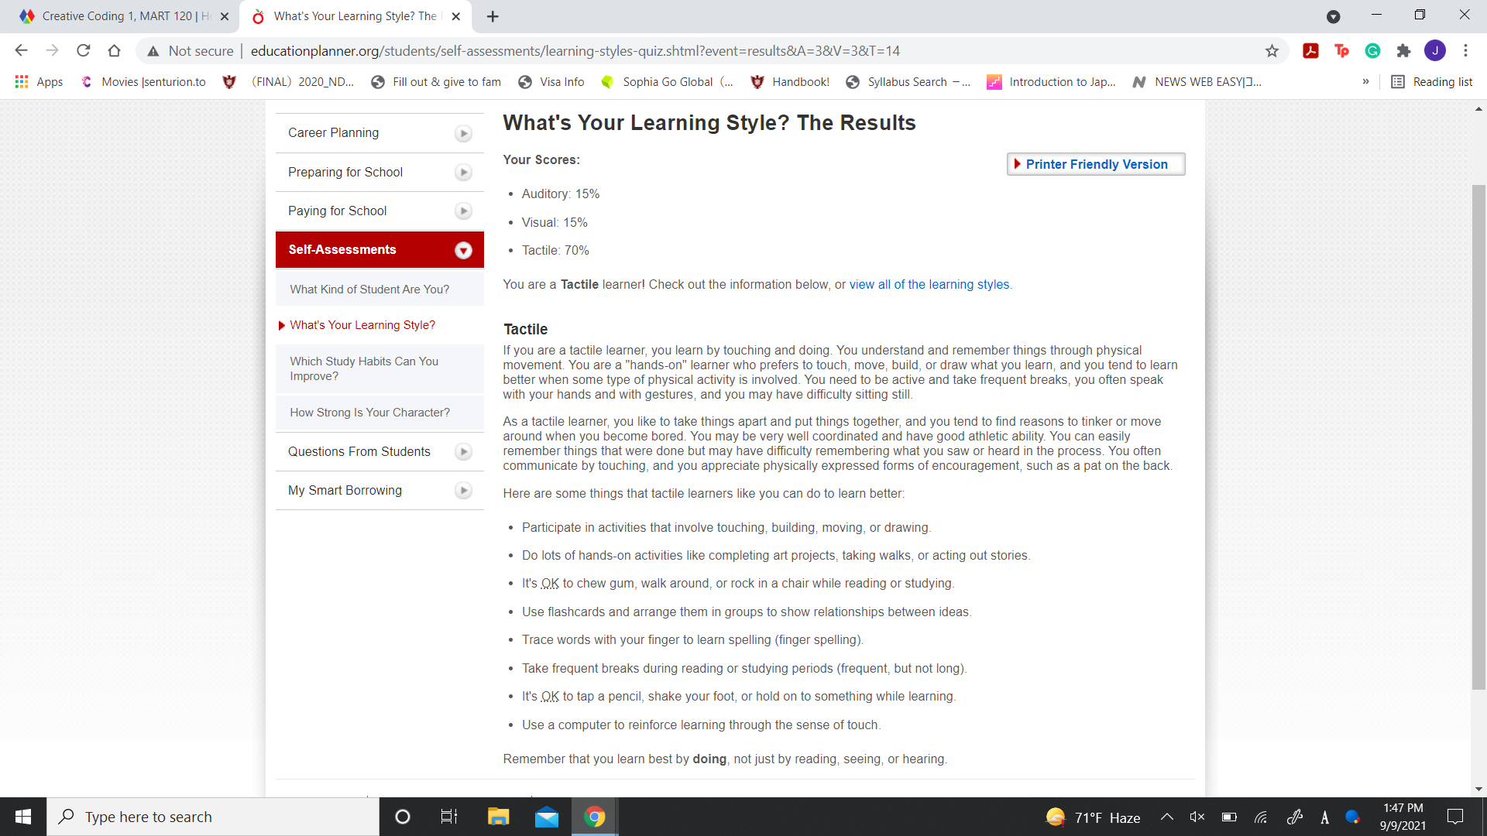

Based on my results, I am a tactical learner, and I fully agree with it. I am definitely a hands-on person when it comes to just about everything. When it comes to coding, I like to test out the executables to understand what a program is doing and then create it myself from there. My guess is that there won’t be executables for this course, but I can get hands-on by drawing out what I think needs to happen and go from there. I like to test things out a lot as well, even if it’s not yet perfect it gives me a better understanding of what to do after and how to go about correcting it. Sometimes the hardest thing for me is getting started.